- Divided Difference Interpolation
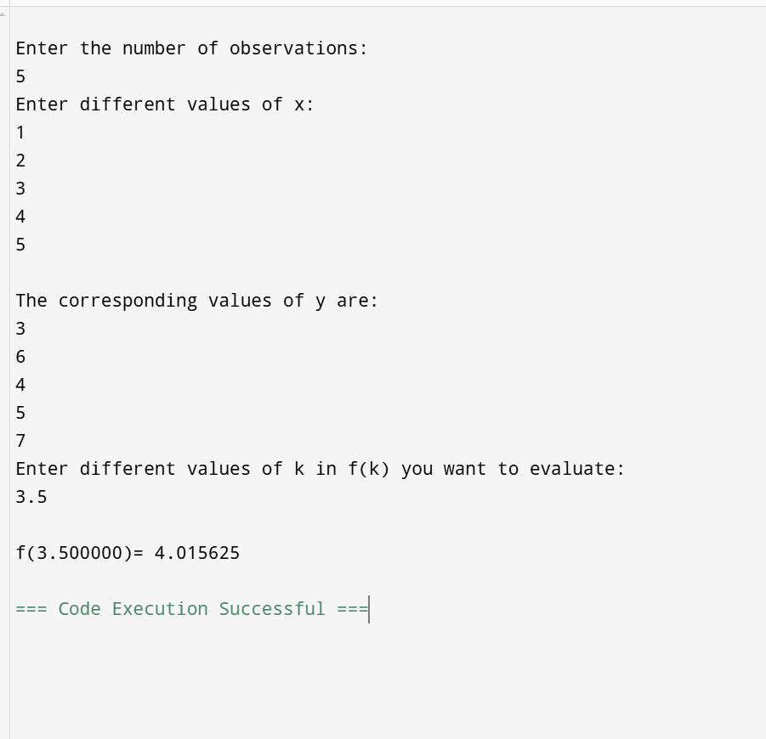
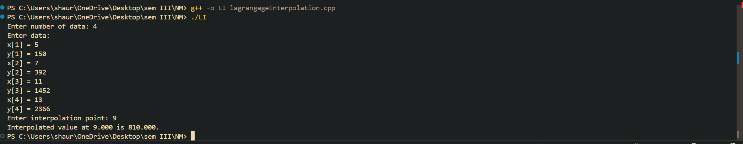
- Linear Regression
- Lagrange’s Interpolation
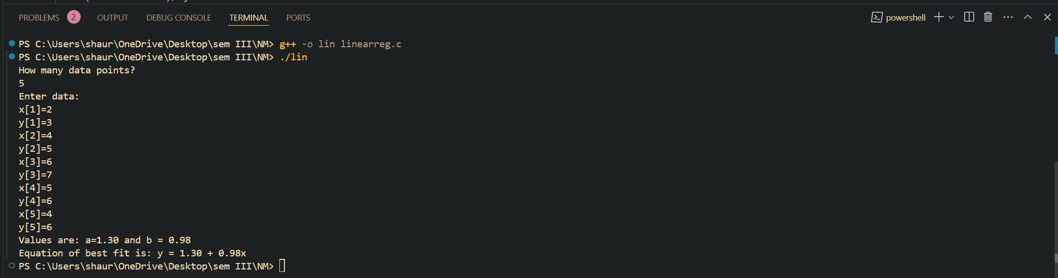

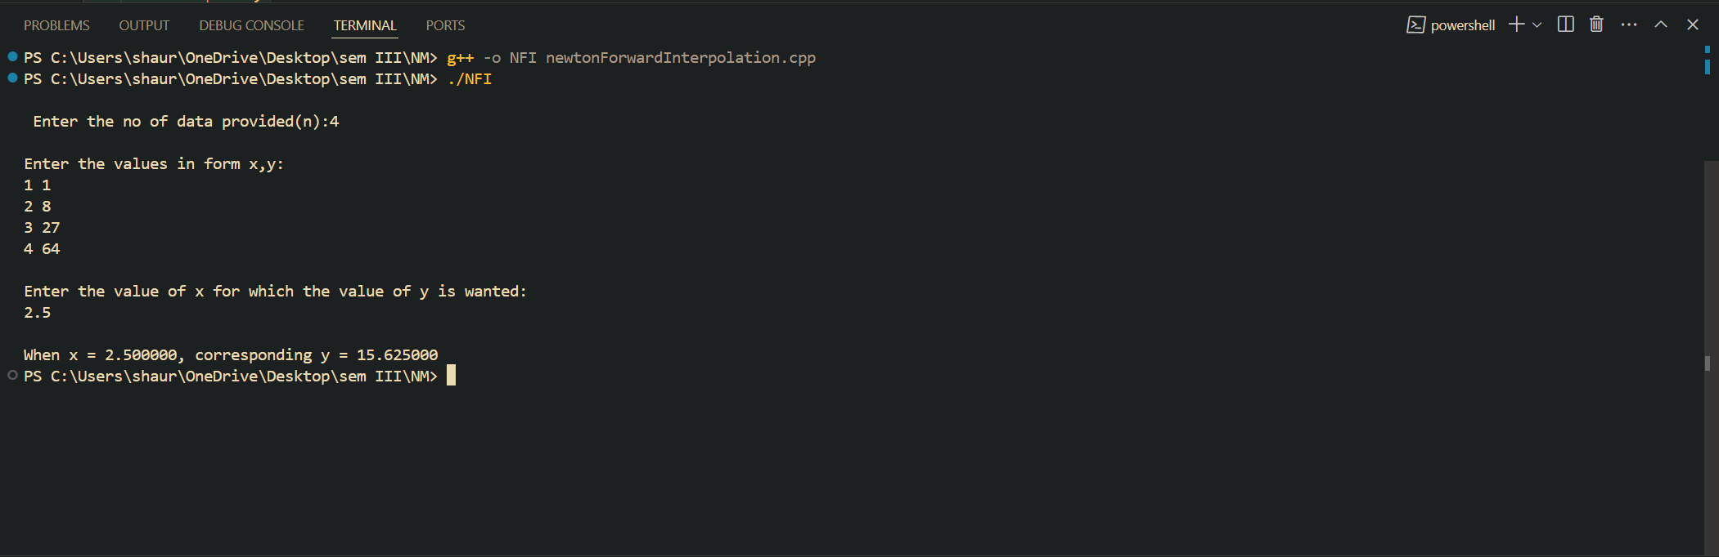
- Newton’s Forward Interpolation

